**Sample Dockerfile for a Node.js application** along with a **detailed explanation of each step** so you understand exactly what’s happening.

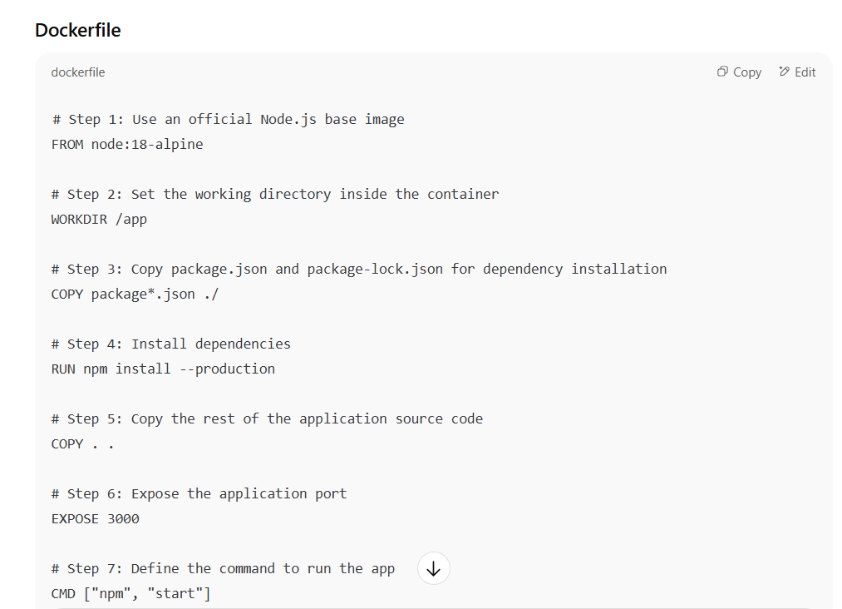

**Detailed Step-by-Step Explanation**

**Step 1: Use an official Node.js base image**

FROM node:18-alpine

* **Purpose:** Defines the starting point for our image.
* **Why node:18-alpine?**
  + **Node:18** → A specific LTS (Long-Term Support) version of Node.js for stability.
  + **Alpine** → A minimal Linux distribution, smaller in size (~5 MB) for faster builds and smaller images.
* This base image already includes Node.js and npm, so we don’t have to install them manually.

**Step 2: Set the working directory**

dockerfile

CopyEdit

WORKDIR /app

* **Purpose:** Sets /app as the working directory inside the container.
* Any following commands (COPY, RUN, CMD) will be executed from here.
* Helps keep the container filesystem organized.

**Step 3: Copy only dependency files first**

dockerfile

CopyEdit

COPY package*.json ./

* **Purpose:** Copies package.json and package-lock.json into the container.
* **Why first?**
  + Docker uses **layer caching** — if dependencies haven’t changed, this step is cached, so the npm install step won’t need to run again on future builds.
* package*.json is a wildcard so it matches both package.json and package-lock.json.

**Step 4: Install dependencies**

RUN npm install --production

* **Purpose:** Installs only production dependencies (skipping dev dependencies) to reduce image size.
* Uses npm’s cache to speed up repeated builds.

**Step 5: Copy application source code**

COPY . .

* **Purpose:** Copies the rest of your application code into the container’s /app directory.
* This is done **after** installing dependencies to take advantage of Docker layer caching.

**Step 6: Expose application port**

EXPOSE 3000

* **Purpose:** Informs Docker (and anyone running the container) that the app listens on port 3000.
* This doesn’t publish the port automatically — you must still map it with docker run -p 3000:3000.

**Step 7: Start the application**

CMD ["npm", "start"]

* **Purpose:** Defines the default command to run when the container starts.
* **Why array format?** It’s the **exec form**, which avoids running through a shell and ensures signals (like CTRL+C) are properly passed to the Node.js process.

✅ **Build & Run Commands**

# Build the image

docker build -t my-node-app .

# Run the container, mapping port 3000

docker run -p 3000:3000 my-node-app